MANAV RACHNA INTERNATIONAL INSTITUTE OF RESEARCH AND STUDIES
Web Technologies (4.5CA152C01)

ASSIGNMENT: II
Name – Yashveer Singh
Class – BCA I B
Roll No. – 24/SCA/BCA(AI&ML)/075

Q1 What does CSS stand for? Name three types of CSS. List three common properties used in CSS for styling text?
Ans- CSS stands for Cascading Style Sheets. It is a style sheet language used for describing the presentation of a document written in a markup language like HTML.
Here are three types of CSS:
- Inline CSS: Styles are applied directly to HTML elements using the style attribute. This is the least preferred method as it mixes style and content.
- Internal CSS: Styles are defined within the <head> section of an HTML document using the <style> tag. This is better for styling a single page but becomes cumbersome for multiple pages.
- External CSS: Styles are defined in a separate .css file and linked to the HTML document using the <link> tag in the <head> section. This is the most preferred method as it separates style and content, making it easier to maintain and reuse styles across multiple pages.
Here are three common properties used in CSS for styling:
- Color: Sets the color of text, background, borders, etc.
- Font-size: Sets the size of the font.
- Background-color: Sets the background color of an element.
Q2 Explain the difference between internal, external, and inline CSS.
Ans- CSS offers three primary ways to style HTML elements: inline, internal, and external stylesheets:
Internal CSS: Is a method of directly embedding CSS rules within the <head> section of an HTML document. This approach is ideal for applying unique styles to a specific page. By using the <style> tag, you can define CSS rules that will be applied to the corresponding HTML elements on that page. While effective for simple styles and small-scale projects, larger projects often benefit from external CSS files for better organization and reusability.

Key Points:
- Scope: Internal CSS styles are limited to the specific HTML document where they are defined.
- Organization: While effective for simple styles, larger projects may benefit from external CSS files for better organization and reusability.
- Performance: Internal CSS can slightly impact page load times, especially for large stylesheets. Consider minifying and combining CSS files to optimize performance.
External CSS: Involves creating a separate .css file to store your styles. This file can then be linked to multiple HTML documents, making it ideal for maintaining consistent styling across an entire website. By separating the styles from the HTML, you improve code organization, readability, and maintainability.
To link an external CSS file to an HTML document, you use the <link> tag within the <head> section. The rel attribute is set to "stylesheet" and the href attribute specifies the path to the CSS file.
Inline CSS: Is a method of applying styles directly to an HTML element using the style attribute. This approach allows for quick style modifications to specific elements, but can lead to less organized and maintainable code, especially for larger projects. It's generally recommended to use external or internal stylesheets for better organization and reusability.
Q3: How does the position: absolute differ from position: relative?
CSS, position: absolute and position: relative are two fundamental positioning properties that allow you to manipulate the layout of elements on a web page. Here's a breakdown of their key differences:
Position: Relative
Normal Flow: The element is still part of the normal document flow, meaning it takes up space and affects the layout of other elements.
Offset: The element is positioned relative to its original position, using properties like top, right, bottom, and left.
Example: If you set top: 20px and left: 30px, the element will move 20 pixels down and 30 pixels to the right of its original position.
Position: Absolute
Removed from Normal Flow: The element is removed from the normal document flow, meaning it no longer takes up space and doesn't affect the layout of other elements.
Positioned Relative to Parent: The element is positioned relative to its closest positioned ancestor (parent). If there's no positioned ancestor, it's positioned relative to the initial containing block (usually the <html> element).
Example: If you set top: 20px and left: 30px on an absolutely positioned element, it will move 20 pixels down and 30 pixels to the right from the top-left corner of its closest positioned ancestor.
Q4: Describe the difference between id and class selectors in CSS.

In CSS, both id and class selectors are used to apply styles to HTML elements, but they have distinct purposes and characteristics:

ID Selectors:
- Syntax: An ID selector is defined with a hash (#) followed by the ID name. For example, #myId.
- Uniqueness: An ID should be unique within a single HTML document. This means that no two elements should have the same ID.
- Specificity: ID selectors have a higher specificity than class selectors. This means that if both an ID and a class selector apply to the same element, the styles defined by the ID will take precedence.
- Usage: IDs are often used for elements that need to be uniquely identified, such as a specific section of a page, a form, or an element targeted by JavaScript.
Class Selectors:
- Syntax: A class selector is defined with a period (.) followed by the class name. For example, .myClass.
- Reusability: A class can be applied to multiple elements within the same document. This allows for styling groups of elements that share the same class.
- Specificity: Class selectors have lower specificity than ID selectors. If there is a conflict, the ID styles will override the class styles.
- Usage: Classes are used for styling multiple elements that share common styles, such as buttons, text formatting, or layout components.
Q5: Use CSS to create a hover effect that changes the text color of a button when a user hovers over it.
<html>
<head>
<style>
. hover-button {
color: black;
background-color: lightgray;
padding: 10px 20px;
border: none;
cursor: pointer;
}
.hover-button: hover {
color: red;
}
</style>
<title>Button Hover Effect</title>
</head>
<body>
<button class="hover-button">Hover over me! </button></body>
</html>

Q6: Style a form using CSS so that the input fields have a specific width, border color, and padding.
<html>
<head>
<title> Form </title>
<style>
.styled-1 {
width: 600px;
border: 2px solid;
padding: 10px;
margin-border:10px;
border-radius: 5px;
border-color: red;
}
</style>
</head>
<body bgcolor="silver">

<h1>FORM</h1>
<form class="styled-1">
<fieldset>
<legend><font color="red" size="5" face="arial"><b>COLLEGE FORM</b></font></legend>
<label for="fname" id="name" ><b>Name:</label><br>
<input type="text" required>
<label for="12th Marks" id="name" class="styled-1"><b> 12th Marks(%):</b></label>
<input type="number" max="100" min="33" required/>
<b> Upload here</b>
<input type="file"/><br>
<label for="Email" id=name required>Email:</label><br>
<input type="Email"/>
<label for="10th Marks" id="name" required class="styled-1" ><b>10th Marks(%):</b></label>
<input type="number" max="100" min="33"/>
<b> Upload here</b>
<input type="file" name="mark sheet"/><br>
<label for="Name" id=name>Father's Name:</label><br>
<input type="text"/>
<font color="red">Charactor certificate</font>
<input type="file" required/><br>
<label for="Course Name" id=name>Course Name:</label><br>
<input type="text"/>
<font color="red">Migration certificate</font>
<input type="file"/><br><br>
<b>Phone No:</b>
<input type="text" size="9" maxlength="10" required/>
<hr>
</fieldset>
</form>
</body>
</html>
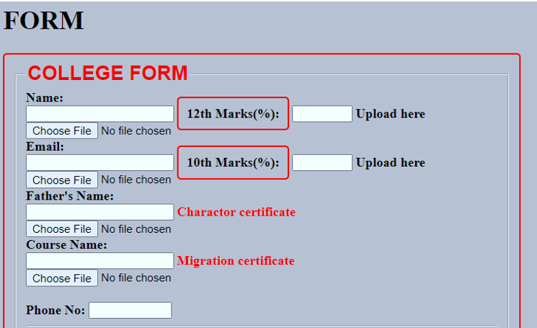
Q7: Break down the structure of a CSS rule and explain each part of it.
Ans: Parts of a CSS Rule:
- Selector (p): This defines the HTML element(s) to which the rule will be applied. In this case, the rule applies to all <p> (paragraph) elements.
- Declaration Block ({}): This contains one or more declarations separated by semicolons. Each declaration is made up of a property and a value.
  - Property (color): This is the aspect of the element that you want to style, such as color, font-size, margin, etc.
  - Value (blue): This specifies the setting for the property. In this case, the color property is set to blue.
3.Declaration (color: blue;): This is a single line within the declaration block that includes a property and a value, ending with a semicolon
Q8: Construct a CSS stylesheet for a form that uses advanced selectors, pseudo-classes, and media queries.
<html>
<head>
<style>
form > input[type="text"] {
width: 100%;
padding: 10px;
margin: 5px 0;
border: 2px solid #333;
border-radius: 4px;
}
form input[type="submit"]:hover {
background-color: #4CAF50;
color: white;
cursor: pointer;
}
form input[type="text"]:focus {
border-color: #555;
}

input:invalid {
border-color: red;
}
input:valid {
border-color: green;
}

@media (max-width: 600px) {
form {
display: flex;
flex-direction: column;
}
form input[type="text"] {
font-size: 18px;
padding: 15px;
}
}
@media (min-width: 601px) and (max-width: 1024px) {
form {
display: flex;
flex-direction: row;
justify-content: space-between;
}
form input[type="text"] {
width: 45%;
}
}

</style>
</head>
<body bgcolor="silver">

<h1>FORM</h1>
<form>
<fieldset>
<legend><font color="red" size="5" face="arial"><b>REGISTRATION FORM</b></font></legend>
<label for="fname" id=name><b>Name:</label><br>
<input type="text" required>
<label for="12th Marks" id="name"><b> 12th Marks(%):</b></label>
<input type="number" max="100" min="33" required/>
<b> Upload here</b>
<input type="file"/><br>
<label for="Email" id=name required>Email:</label><br>
<input type="Email"/>
<label for="10th Marks" id="name" required ><b>10th Marks(%):</b></label>
<input type="number" max="100" min="33"/>
<b> Upload here</b>
<input type="file" name="mark sheet"/><br>
<label for="Name" id=name>Father's Name:</label><br>
<input type="text"/>
<font color="red">Charactor certificate</font>
<input type="file" required/><br>
<label for="Course Name" id=name>Course Name:</label><br>
<input type="text"/>
<font color="red">Migration certificate</font>
<input type="file"/><br><br>
<b>Phone No:</b>
<input type="text" size="9" maxlength="10" required/>
<hr>
</fieldset>
</form>
</body>
</html>
